 | Wairarapa A & P Show  27-29 October 2023  144th Annual Show



www.newworld.co.nz/lower-north-island/manawatu-and-wairarapa/carterton/

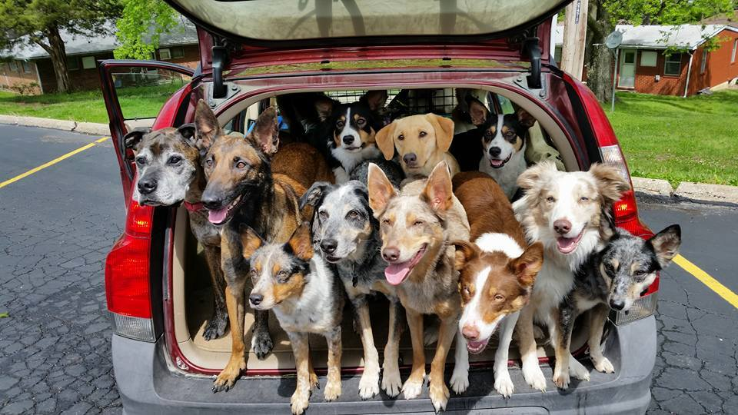
PET DOG COMPETITION

Sunday 1.00pm
Entertainment Area through Gate 2
Chester Road

ENTRY FEE: $5.00 per dog/per class
Entries must be received at the Wairarapa A & P Office on or before Thursday, 26 October 2023

Entries can either be posted or emailed
Details on entry form

PRIZES: Sponsors products subject to availability
Ribbon 1st to 3rd
Champion and Reserve Champion ribbons awarded

Evidence of treatment for Sheep Measles such as a treatment certificate or receipt from vet may be required. Bring along your dogs vaccination books as all information should be in there

All dogs must be leashed and under the control of the exhibitor at all times, unless otherwise requested by the Judge for the purpose of judging. Mum and Dad are able to help.



Working Dogs

This is working dog breeds or a farm working dog

Class 901 Working Dog - Smooth Coat

Class 902 Working Dog - Rough Coat

Champion Working Dog and Reserve Champion
Selected from 1st and 2nd place getters of classes 901 and 902


Pet Dogs
All dogs welcome

Class 903 Childs Pet Dog
To be led by child under 12 years of age

Class 904 Open Pet Dog - Large (any breed)

Class 905 Open Pet Dog - Small (any breed)

Class 906 Pet Dog – Purebred

Class 907 Open Cross Breed

Class 908 Rescue Dog – Large

Class 909 Rescue Dog - Small

Champion Pet Dog and Reserve Champion
Selected from 1st and 2nd place getters of classes 903 to 909

Class 910 Consolation Class for Non-Ribbon Winners

Fancy Dress
There will be a 10 minutes gap at the end of
the Pet Dog classes so everyone has time to get dressed up
Ribbons 1st to 3rd

Class 911 Matchy Matchy!
(dress you and your dog up to match)

Class 912 I'm a Tradie!
(dress your dog like a Tradie)

Champion and Reserve Champion from classes 911 and 912



Pet Dog Section Entry Form

144th Annual Wairarapa A&P Show
Sunday 29th October 2023

Class  Number | Entrants Name | Dogs Name | Total $ | Note

Entry Fee Total $________

PLEASE PRINT CLEARLY

Name of Exhibitor: ……………………………………………………………….........

Postal address: …………………………………………………………………………

……………………………………………………………………………………...........

Phone No. ……………………Email address……………………………………….

ENTRIES CLOSE ON THURSDAY 26th October 2023

One entry form per dog
Send all entries to address below along with payment or email entry to office@waiaps.org.nz and deposit entry fee to below account with surname as reference: 02 0608 0018129 00

The Secretary, PO Box 16, Carterton
Ph. 06 379 8124
Email: office@waiaps.org.nz
www.wairarapashow.co.nz

